BUILDING A BETTER CASE REVIEW TOGETHER
Re-evaluate*Re-Invigorate*Re-Energize

INTRODUCTION

The intent of this template is to help you expand and enhance your Case Review process. It was developed by the Northeast Regional Children’s Advocacy Center (NRCAC). These guidelines, along with an online training in 2018, will help your staff and MDT plan and evaluate your case review process.

Content included in this guide:
- Why case review is important
- Creating/Evaluating Case Review Protocol
- Ground Rules/Guiding Principles
- Draft Protocol
- Sample Case Review Agendas
- Role of the Facilitator
- Case Flow Charts
- Resources
- Regional contact information

WHY SHOULD I ATTEND CASE REVIEW

Since all CACs are multidisciplinary by nature, regularly scheduled case review or regular MDT becomes the formal process through which professionals share facts and observations that inform team decisions and assist participating professionals to make decisions about cases. Case review is a core standard of an accredited member CAC program. Case review allows the CAC to monitor cases and bring the knowledge, experience and expertise of the team members together. Through case review, the efforts of all team members are maximized because knowledge is shared and cooperation is built among the participating agencies. Case review presents an opportunity for each professional to share their unique knowledge and skill with the other team members and allow for full discussion on determining the optimum case plan and next steps.

Each CAC determines, with their multidisciplinary team, the criteria for case review – are all cases reviewed or just identified/complex cases. The more complicated cases are usually reviewed on an ongoing basis until all efforts on the case have taken place and the case is closed. Case review should present opportunities to:

- Evaluate the child’s interview
- Discuss, plan and monitor the progress of the investigation, including what has been done and what still needs to be done on the case
- Review the findings from the medical examination
- Discuss protection issues, if needed, and provide input into the decision about removal of the child from the family
- Discuss support issues for non-offending caregiver and other family members
- Discuss cultural considerations of child and non-offending caregiver
- Provide input into the decision about prosecution
- Provide an opportunity to discuss the treatment issues/needs for the child and other family members
- Review the family’s viewpoint about prosecution
- Coordinate criminal and civil proceedings
- Review criminal and civil case proceedings
- Promote joint decision making on case management issues
- Determine appropriate time frames to accomplish tasks
- Provide an opportunity for formal and informal communication among all responsible agencies
- Discuss the important child development issues relevant to interviewing the child, assessing their ability to participate in court, and preparing them for court
- Provide support to the professionals who work the child abuse cases to prevent burnout
- Build trust and support among team members
- Provide cross-training opportunities for team members.

Case review has many benefits:
- Provides an opportunity for new agency personnel to become acquainted with other team members and the case review process
- Allows each team member to retain their agency identity/mandate while becoming familiar with the other systems involved with abused children and their families
- Helps prevent cases from “falling through the cracks” in the system
- Enables team members to identify gaps in resources and conflicts in service provision
- Ensures pro-active planning and case coordination in the best interest of the child and family
There are also many challenges with case review:
- Irregular attendance
- Turnover
- Lack of trust/respect
- Tension between individuals
- Tension between agencies
- Dominated by one individual/discipline
- Team burn out
- Reluctance to share information
- Unclear purpose
- Wrong people at the table
- Focus on investigation only and not ongoing services

Every CAC will set its own policies and procedures for case review. Case review should be coordinated and scheduled by CAC staff, preferably at the CAC. Someone should be designated as the case review facilitator. At some CACs, this facilitator is the CAC Director/Coordinator in others, an MDT member such as, prosecutor is the facilitator.

At case review, all agencies or professionals who have information about a case should be present. Each agency should be present so that all issues pertinent to the case can be discussed, decision making can occur, and appropriate referrals made. Some agencies send the ongoing caseworker/detective, while others send the supervisors with the latest case updates. Each CAC should have a policy about confidentiality of case review information and all those in attendance at case review must be bound by the CAC policies on confidentiality.

It is very important that the agency professionals see case review as valuablel rather than a waste of time. To that end, certain policies about case review should be established early in the process and reinforced by the facilitator and those present. Different CACs have structured their case review in different ways. Some of the very helpful aspects are:

- Develop an agenda for each case review meeting that is distributed ahead of time to the attending agencies and professionals.
- Make certain that the case review agenda lists the important issues to be discussed about a case so that all those in attendance are clear if there are activities that they should have completed prior to case review.
- Make certain that any outstanding cases are regularly reviewed until the case is closed by all of the agencies involved.
- Make certain that case review is an opportunity to monitor case progress and not a time to attack other agencies for their perceived lack of work.
- Ensure all team members understand they can request a case to be put on the list for review.

CREATING/EVALUATING CASE REVIEW PROTOCOL:

- Identify case review practices/guidelines
- Review purpose, location, case review criteria, documentation, confidentiality with MDT
- Create/review guiding principles
- Evaluate how things are working at the present time (OMS MDT surveys)
- Review/update protocol to fit your CAC needs

EXAMPLES OF CASE REVIEW GROUND RULES/GUIDING PRINCIPLES
Note: These Guidelines should be created to reflect the individuality of your team. Some teams do this exercise at the beginning of a regular scheduled case review and then post on the wall of the team room)

- The content of team/case discussions will remain confidential.
- We will bring a positive problem-solving attitude to each meeting.
- Everyone will engage in active participation and will allow everyone to contribute.
- We will respect differences and will not discount others’ opinions, be those personal or case specific.
- We will support each other, rather than judge each other.
- We will refrain from instructing other team members on their job responsibilities.
- We will understand that each agency maintains ultimate authority for decisions appropriate to its own policies and statutory mandates and may not be able to adopt some team recommendations.
- We will understand that each agency has its own policies and procedures and will refrain from using case review as a medium to criticize other agencies’ procedures.
- Feedback will remain open, honest, and constructive and will focus on the case and group process, not on personalities. Adverse personal comments or attacks are not acceptable.
- Our focus will remain on the cases, subsequently avoiding sidetracks, sidebar conversations, personality conflicts, or hidden agendas.
- We will make every attempt to use time wisely by arriving on time for case review/staffing, returning on time from breaks and ending meetings on time.
- We will notify the CAC of any absence from a scheduled review within 48 hours, when possible.
- If a designated Team member cannot attend a scheduled case staffing, a designee and/or his/her supervisor will come prepared to staff the case in his/her absence.
- Barring an urgent situation, we will make all attempts to not leave a case review until the meeting or staffing is adjourned,
- If someone misses a meeting or must leave early, a responsible party will be designated to provide the missed information to the absent MDT member.
- Each team member is responsible for what he/she receives from case review and will ask for what they need from the facilitator and/or other team members.
- To minimize disruptions, cell phones will be turned to vibrate or silent.

EXAMPLE OF A DRAFT PROTOCOL
Note: Each Case Review Protocol should be created with the MDT to reflect the individuality of the program

1. Purpose:
The purpose of Case Review is to bring together the multidisciplinary team (MDT) players to discuss the status of all child abuse cases or identified child abuse cases. Case Review will allow the CAC to track the status of active cases in which both criminal and civil matters are pending and to coordinate interagency services.

2. Participants:
Representatives from the CAC, Child Protection, Prosecutor’s Office, Law Enforcement, Mental Health Agencies (or consultant), Medical representative, and Victim Advocacy will attend and provide input at the monthly/bimonthly/weekly Case Review. If a team representative is not available to attend Case Review, they will ensure that the appropriate information is conveyed to the Case Review Facilitator or another appropriate team member. The participants are direct staff working on the case, or their supervisors, to ensure they are familiar with the case status and case review protocol. The CAC Director or other team member will act as the Case Review Facilitator and other team members will cover in his/her absence.

3. Frequency:
The CAC hosts case reviews meetings monthly/bimonthly/weekly. Additional Case Reviews will be scheduled as needed, according to volume of case referrals and urgency of review.

4. Case Selection:
Cases will be selected by the CAC staff/team members. The Case Review Facilitator will regularly consult with other team members to decide which cases will be reviewed at case review. After the cases are chosen, the Case Review Facilitator will circulate the case list a week before scheduled to allow team members to prepare their updates. The list can be circulated via email (encrypted if need be). Case Review will include sexual and physical abuse cases, as well as child witness to violence cases.

5. Meeting Format:
An agenda with the list of cases scheduled for review will be distributed at the beginning of case review by the Case Review Facilitator. Each case will be discussed in accordance with the Case Review Outline. Individual Team Members will give an overview of the case and relevant issues except for privileged mental health information (including but not limited to names of providers and/or agencies) or privileged Victim Advocacy information. Following the review, MDT members may decide to schedule a follow up Case Review Meeting for a future date. Team members may rotate through Case Review as certain team members (i.e. law enforcement and DCF) may be different for each cases. At the end of the agenda, there is always an opportunity for the MDT team to discuss training, updates, issues and needs.

6. Location of Meeting:
All case review meetings will be held at the CAC (or other location) unless otherwise specified.

7. Documentation:
It is the responsibility of each participant to gather the relevant information for his or her own agency. All updates from case review will be entered into NCA trak directly/outlined in a case review form/recorded by the case review facilitator/recorded by each team member. The case review agendas are returned to the Case Review Facilitator or their designee at the end of each meeting to be shredded. A subsequent email will be sent to team members who were unable to attend.

8. Confidentiality:
Case Review Meetings will take place only for cases that have been formally referred to the CAC, pursuant to ___________, that allows communication among agencies working on child abuse cases.

9. Additional training opportunity:
Case review meeting provide opportunities for MDT members to increase understanding of the complexity of child abuse cases. Case review can provide time for formal and informal training and sharing of information on a regular basis.

SAMPLE CASE REVIEW AGENDAS

Agendas are needed to outline the list of cases that will be discussed. Some CACs print a report using NCA Trak or other database used. Agendas with case names may be circulated by email (sometimes encrypted email if needed) and can be collected for shredding at the end of case review if there is a concern about discovery.

Example 1
- Discuss the Interview – Disclosure and Allegations (FI)
- Identify and discuss other contributing factors (DA/LE/CPS/MD/MH/VA)
- Identify and discuss the impact of cultural, cross cultural, development and disability issues present in the case (CAC/E/CPS/MD/MG/VA)
- Discuss the progress of criminal investigation and disposition (LE)
- Discuss child protection and other safety issues and disposition (CPS)
- Review the medical evaluation, lack of medical evaluation, possible need for evaluation (MEDICAL)
- Discuss the emotional support and treatment needs of the Child and NOC (VA/MH)
- Assess the family’s reactions and response to the child’s disclosure – who, if anyone, is supportive of the child? (VA/LE/CPS/MH/MD)
- Provide input on prosecution and sentencing decisions – discuss disposition (DA/VA/MH/MD/LE/CPS)
- Discussion about who will provide court education and support (VA)

Example 2

Case Overview: | - Type and nature of abuse (allegations)  - Presence of other problems, such as domestic violence, substance abuse, etc.
Cultural Competency: | - Developmental, disability or cultural concerns  - Family’s reactions and response to the child’s disclosure  - Family’s reaction to the involvement of the criminal justice/child protection systems
Investigative Outcomes: | - Interview outcomes  - Progress of the investigation  - Child protection concerns/safety issues
Victim Advocacy: | - Emotional support needs of the child and non=offending family members and strategies for meeting those needs
Medical: | - Medical exam conducted? Findings?
Mental Health: | - Treatment needs of the child and non-offending family members and strategies for meeting those needs
Court Involvement: | - Prosecution status/decisions  - Provisions for court education and court support
Case Outcomes: | - Agency dispositions, including review of criminal and civil (dependency) case dispositions and sentencing

ROLE OF FACILITATOR

The facilitator for Case Review has many responsibilities and requires a unique set of skills, including:

Skills for facilitating groups
Thinks of the group as a resource Stays impartial
Observes keenly Tracks and manages pace
Remains flexible Draws members out
Paraphrases input Tracks themes
Encourages divergent views Uses silence intentionally
Keeps discussion balanced Leads go-rounds in structured manner
Brainstorms Frames concepts, ideas, instructions
Sets up and debrief activities Comments on group process
Implements decision making processes Manages conflict
Evaluates meetings

CASE FLOW CHART

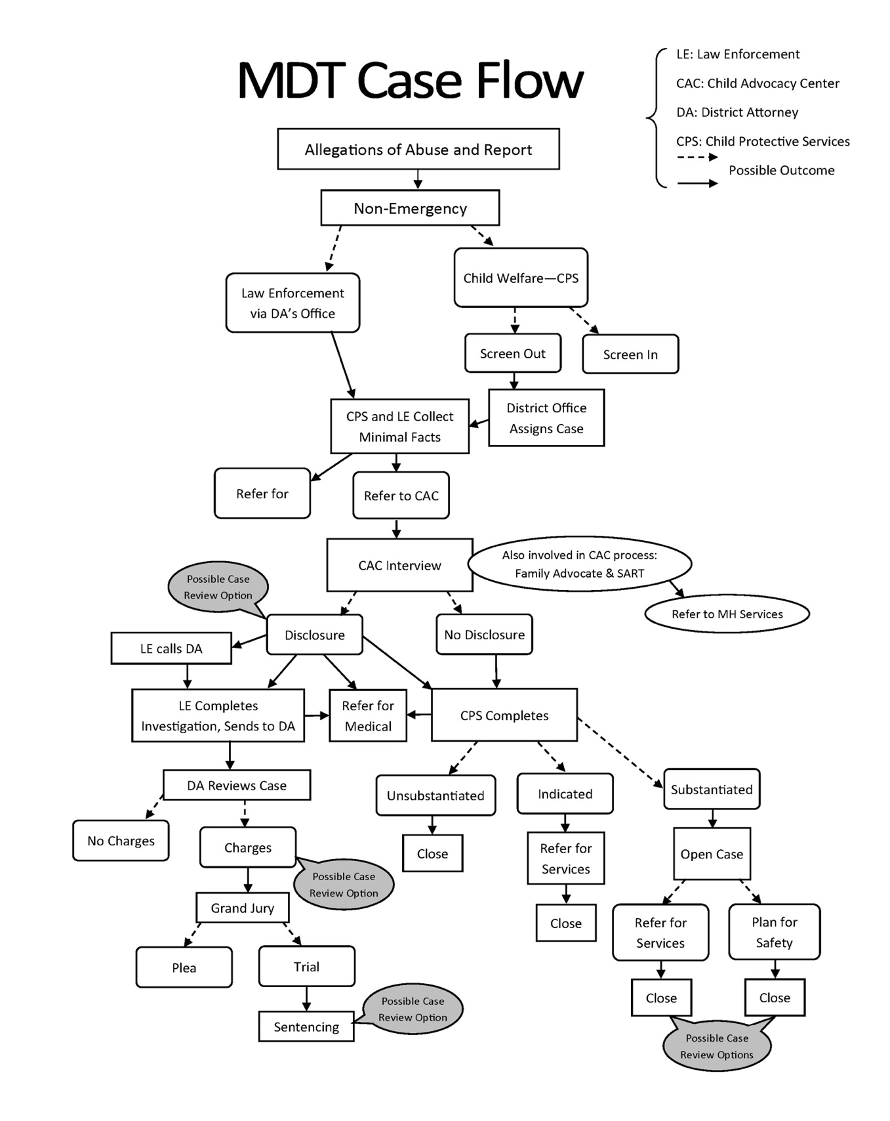

CASE REVIEW MEETING
CONFIDENTIALITY AGREEMENT/ATTENDANCE SHEET
MEETING DATE:
As a member of the ___________________ CAC/ MDT, I, within the bounds allowed by law, agree to maintain the strict confidentiality of all records and information on cases presented at Case Review Meetings. I further agree not to release any records or information on any child or adult seen at the Center or their families, except as it relates to the legitimate program operations of my agency. I agree that no general media or public access to information will be allowed and that I will not discuss cases outside the confines of the Multidisciplinary Team with family members, friends, or other inappropriate parties that could hinder the confidentiality and privacy that we ensure for each child and family, and adult client.
NAME | AGENCY
THIS FORM MUST BE SIGNED BY ALL INDIVIDUALS ATTENDING CASE REVIEW

OTHER RESOURCES

Case Review Planning Guide
Developed by the National Children’s Alliance, this guide offers a number of helpful considerations for developing and bolstering case review and team development.

Online Accreditation Bootcamp
Includes expert interviews; presentations by Teresa Huizar, Executive Director of the National Children’s Alliance; and supportive documents for each of the standards, including case review.

Contact Information for additional support from Regional CACs

Midwest Regional Children’s Advocacy Center
5901 Lincoln Drive, Edina, MN 55436
Phone: 952-994-5277 * www.mrcac.org

Northeast Regional Children’s Advocacy Center
300 East Hunting Park Ave, Philadelphia, PA 19124
(215) 387-9500 * www.nrcac.org

Southern Regional Children’s Advocacy Center
210 Pratt Ave., Huntsville, Alabama 35801
Tel: 256-533-5437 * www.nationalcac.org/southern-regional-child-advocacy-center/about-srcac.html

Western Regional Children’s Advocacy Center
Chadwick Center for Children and Families, Rady Children's Hospital San Diego.
MC 5016, 3020 Children's Way, San Diego 92123
Tel: 858-966-1700 ex 6581 * www.westernregionalcac.org

